CS103 PROJECT MINI AMAZON

Muhammad Ali Mahmood

2021346

Problem statement:

Mini amazon contains different categories and different items. Users can buy multiple items and we have to calculate the total bill, shipping, and tax.

Introduction:

In this program, we’ve to build an online shopping system. We’ve given the user different categories such as electronics and if the user enters a particular category we output the items in that category. We ask the user if they want to shop more. In the end, we calculate the bill, shipping, and tax

Code Description:

* We have created a CSV file with all the categories and items with

price in it.

In this code, we are reading from the CSV file.

We are saving the data in a vector named all_data.

Csv is comma separated values .

We have to separate each box with the help of a comma.

We give the users a choice to select any of the categories and we display the items of that particular category.

We ask the user what they want to buy and add it to the cart.

We ask the user if they want to continue shopping and if they say yes then all the categories are displayed again.

If the user says no then we calculate the bill, shipping, and taxes.

Tax is calculated by 5 percent of the overall bill.

Shipping is calculated by 1 percent of the overall bill.

Code, when a user buys an item we have to update

the file with updated stock so we are creating a new file

named new data and transferring the new information in

that file, and deleting the old file.

Flowchart: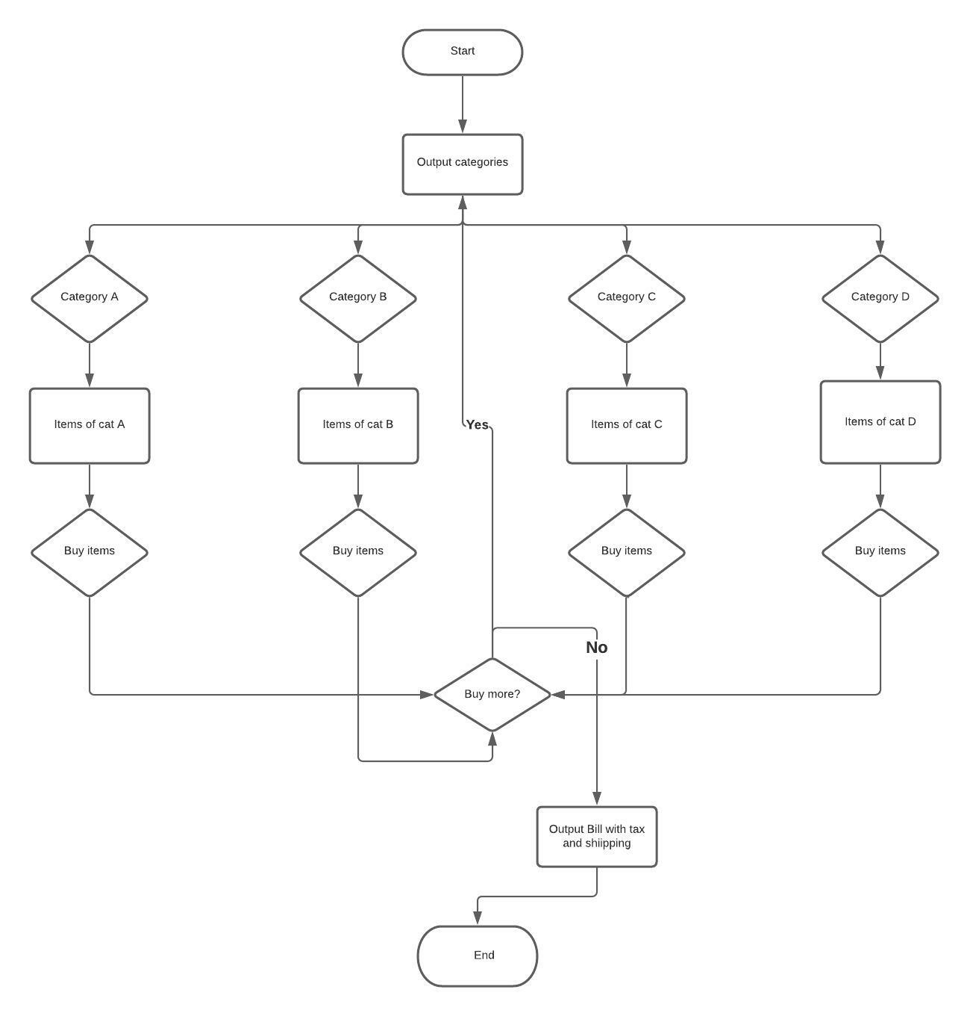

* Conclusion:  
  Programs like these are very efficient and useful. We should make more projects/programs like these which are useful in our real life.